**Introduction:**

That’s a lot of data in need of processing! Let's say Invoices, contracts, human resources (HR) forms etc., businesses across the world spend countless hours reading documents, pulling information from them, and making sure the correct action is taken based on that information. It’s a daily routine for employees to focus

on manual, time-consuming work instead of the higher-value tasks that drive business objectives and company growth.

Fortunately, there’s a solution. You can minimize the manual, routine work of data processing and get your employees back to higher-value tasks.

Advances in Artificial Intelligence (AI) have led to the development of software robots that can read documents of any difficulty, pull desired information, and pass it to where it needs to go.

***Teaching Robots to understand documents using AI and ML techniques for data extraction & interpretation. It is the fast & flexible technology for accurate document processing***

UiPath Document Understanding combines robotic process automation (RPA) and artificial intelligence (AI) to help you extract and interpret data from different documents and ensure end-to-end document processing.

UiPath Document Understanding addresses complex document processing and eliminates manual extraction headaches by having robots read, understand, and act on documents using their automated intelligence skills. These robots can work at speeds and with a high accuracy eliminating the risk of errors.

If you need to find out if a person has American citizenship, you can quickly find it in their passport. But with other documents, like legal forms or bank statements, it can be difficult and time-consuming to validate the information. It becomes even more complex & difficult if the volume is huge & also it is risky as it might involve human errors while processing. DU is the solution for all of the above.

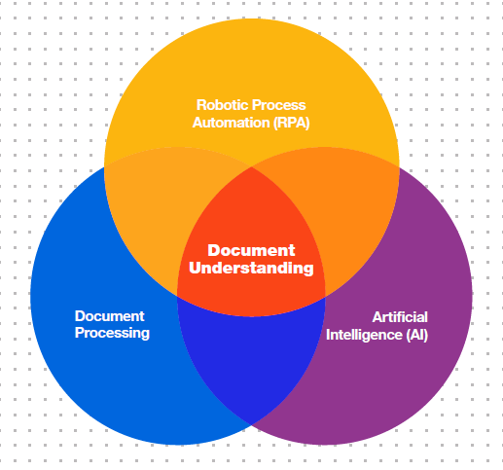

**Benefits:**

1. Fast, accurate, and flexible document processing with AI combination of different approaches help process various types and formats of documents. Even if the format of the document changes, AI can still determine & extract the data.
2. **Intelligence**: Built to process various document types with Intelligence - Your documents come in many layouts and formats, whether they’re fixed forms or unstructured ones; whether they contain tables, handwriting, checkboxes or signatures; whether they’re rotated, skewed, or low-resolution, the robots can understand and act upon documents. They can ask for employee validation if needed and will automatically learn from the human validated data.
3. **Accuracy** improving over time - The more you work with these models, the more trained and accurate they become. This eliminates the risk of human error, thus, ensures compliance and reduces time employees spend on rework.
4. **Efficiency**: Accelerate operational efficiency: Spend less time and costs on high-volume document processing and more on the real business investments
5. **Human validation:** In the case of any inaccuracies, low confidence scores, or exceptions, robots ask for help to confirm the data.
6. **Retraining capabilities:** You can label documents and retrain ML models in AI Center to help robots understand the specificities of your documents. Similarly, the models can be continuously retrained based on the human input in the Validation Station and Classification Station. This means that the more you work with the model, the more effective it becomes. Thus, the accuracy of the output improves over time.

**Framework:**

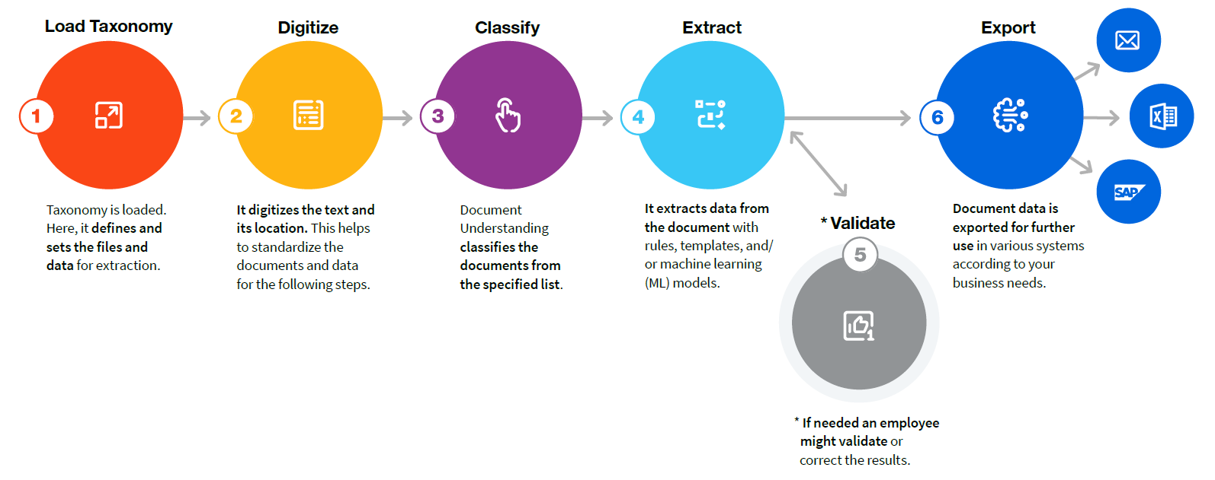

**Taxonomy**:

What documents need to be processed and what data is required from them? Used to define the document types and the pieces of information targeted for data extraction (fields) for each document type and formalizes this information into a dedicated Taxonomy structure.

**Digitize**:

What does this file contain? Used to obtain the textual content and the structure of the incoming document, turning a file into machine-readable content so it can be further processed downstream.

Extracts the DOM & document text. DOM generally contains all the basic information of a document. Such as document name, document class, text length, number of pages and all other page information.

**Classify**:

Classification of the documents for bot to understand the document type it is dealing with. Used to automatically determine what document types are found within a digitized file.

**Extract**:

**Types of documents:**

Special cases: Handwriting, Signatures, Checkboxes, Different other languages (Middle Eastern, Asian, or Indian scripts)



**Types of Extractors:**

UiPath Document Understanding can use either a rule-based or a model-based approach, or those can be combined into a hybrid approach.



A rule-based approach takes actions based on specific, user-specified rules. Template based approach take actions based on the sample template & custom areas we will have mentioned. Example: Regex extractor & Form extractor.

Machine Learning models learn how to respond to dynamic situations. This means they are taught how to find and extract data when no static rules or templates

can be applied. This is done by exposing them to a dataset and telling them how to act in different situations. Once taught, the ML models can apply what they’ve learned to unforeseen events. ML models need time to learn. They can be also retrained based on your custom data – the more you work with the model, the more accurate results you’ll get. Example: ML Invoice Extractor, ML Receipt extractor etc.

Hybrid Approach: When you need to combine rules, templates, and ML models to ensure more effective data extraction.

This draws upon specific, pre-determined rules to extract structured data, while also using ML models to recognize and process less structured parts of a document. Correspondingly, this combination grants higher accuracy. Different extractors are set up separately for each document or even field.

**Conclusion**

Every day businesses spend a lot of time reading, understanding, and processing document data. Here it is demonstrated how automating these process can save businesses both money and time. The documents may come in many different formats, such as structured, unstructured, or semi-structured. They may have special parts such as handwriting or checkboxes, UiPath Document Understanding has been built to address all these needs.